**WEEK-5**

Microservices Mandatory hands on

ACCOUNT

**AccountApplication.java**

package com.cognizant.Account;

import org.springframework.boot.SpringApplication;

import org.springframework.boot.autoconfigure.SpringBootApplication;

*@SpringBootApplication*

public class AccountApplication {

public static void main(String[] args) {

SpringApplication.*run*(AccountApplication.class, args);

}

}

**AccountController.java**

package com.cognizant.Account;

import org.springframework.web.bind.annotation.GetMapping;

import org.springframework.web.bind.annotation.PathVariable;

import org.springframework.web.bind.annotation.RestController;

import java.util.Map;

*@RestController*

public class AccountController {

*@GetMapping*("/accounts/{number}")

public Map<String, Object> getAccount(*@PathVariable* String number) {

return Map.*of*(

"number", number,

"type", "savings",

"balance", 234343

);

}

}

**OUTPUT:**

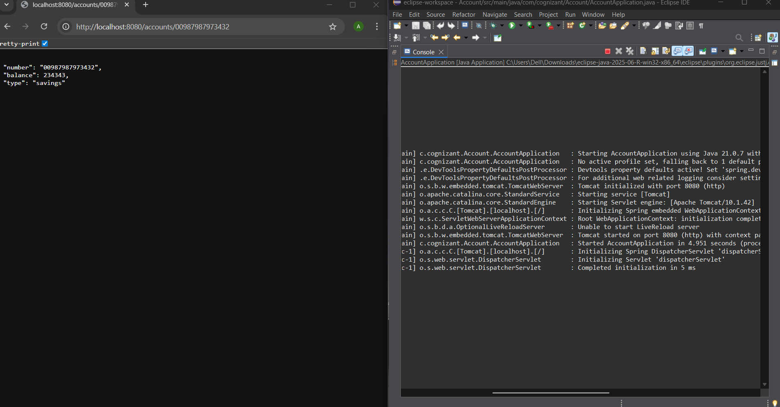

**LOAN**

**LoanApplication.java**

package com.cognizant.loan;

import org.springframework.boot.SpringApplication;

import org.springframework.boot.autoconfigure.SpringBootApplication;

*@SpringBootApplication*

public class LoanApplication {

public static void main(String[] args) {

SpringApplication.*run*(LoanApplication.class, args);

}

}

**LoanController.java**

package com.cognizant.loan;

import org.springframework.web.bind.annotation.GetMapping;

import org.springframework.web.bind.annotation.PathVariable;

import org.springframework.web.bind.annotation.RestController;

import java.util.Map;

*@RestController*

public class LoanController {

*@GetMapping*("/loans/{number}")

public Map<String, Object> getLoan(*@PathVariable* String number) {

return Map.*of*(

"number", number,

"type", "car",

"loan", 400000,

"emi", 3258,

"tenure", 18

);

}

}

**OUTPUT:**

